Name: ___________________________ Date: 3/20/17 Period: ___

**Group 1**

Global 1: Spread of the Black Death Timeline **The Origins of the Plague**

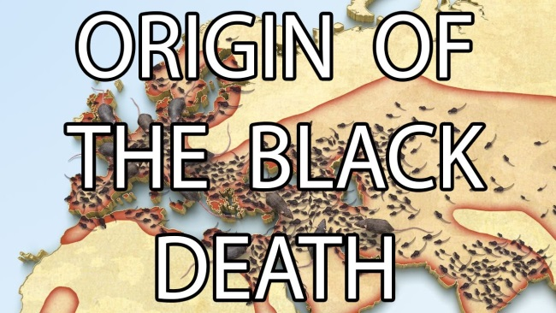 The Black Death was the nickname given to a terrible outbreak of Bubonic Plague that devastated the population of Europe during the Medieval Period. The Black Death is best remembered for the effects that it had on the population of Europe but it actually started thousands of miles away in Asia. It is important to understand where the disease began in order to understand how and where it spread to. According to primary sources, the Black Death began in **China** in the year **1338 AD**.

The Black Death killed over 200 million people but most reports focus on the death and suffering in Europe even though people in Asia and the Middle East died as well.

What is this Europe-centered pattern an example of?

1. Ethnocentrism C. Bipartisanism
2. Centrifugal force D. Frugality
3. According to primary sources, where and when did the Black Death begin?

____________________________________________________________________________________________________________________________________________________________

The first mention of plague was found on grave stones near Lake Issk Kul in Kyrgystan (Ker-geh-stan). Social Scientists believe that the disease called **Yersinia Pestis** (a bacteria) spread from Kyrgystan into the large populations of China where it became an **epidemic** (large numbers of people are infected very quickly). China was ruled by the Mongol Yuan Dynasty at the time and the government did very little to stop the spread of the disease. Mongol armies then carried the disease with them as they left China in 1340 AD to conquer new lands and inadvertently spread the plague to the rest of the world.

The Black Death was caused by the bacteria *Yersinia pestis* which is too small to be seen without a microscope. The Mongol and Chinese soldiers couldn’t see the germs so they didn’t know that they were carrying it.

Do you think the disease would have spread if the Mongols had modern-day medical technology? Why or why not?

____________________________________________________________________________________________________________________________

1. How did the Black Death spread outside of China in 1340 AD?

____________________________________________________________________________________________________________________________________________________________

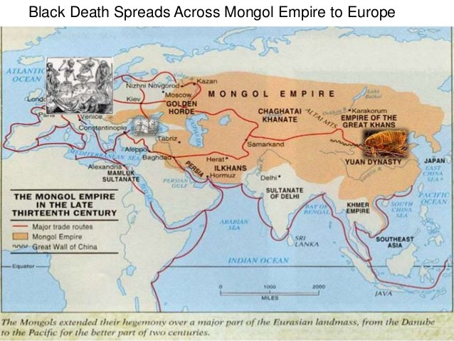The disease was carried mainly by **fleas** that lived on the **rats** that were hiding in the Mongol army caravans. As the Mongol army traveled along the **Silk Road** in between 1340 AD and 1346 AD, the disease spread into India and the Middle East. Millions of people died in India because they had no natural **immunity** to the disease. The Mongols indirectly introduced the plague to Europe when they met merchants from the Italian city-state of Genoa (Jeh-no-ah) near the Black Sea. The Mongols and the Genoese (people from Genoa) met at the city of **Kaffa** in 1346.

The Black Death spread west towards Europe from China thanks to the expansion of the Mongol Empire. Huge Mongol armies (who didn’t know they had it) accidently spread the disease to every region they conquered in the 1300s.

How do you think the people of Europe felt when they heard that a huge army that kills everything in its path was coming? Why?

_________________________________________________________________________________________________________________________________________________________

1. How did the Black Death spread from China to India and the Middle East between 1340 and 1346 AD?

____________________________________________________________________________________________________________________________________________________________

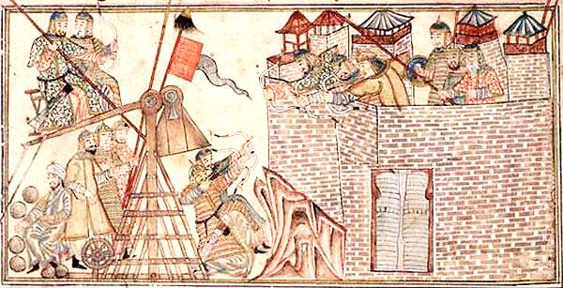The Genoese had taken cover behind the walls of the fortress city of Kaffa in 1346 when they heard that the Mongols were coming. The Mongols reached the city and laid **siege** to it for 11 months. During this time the Black Death started killing thousands of Mongol soldiers which weakened their armies. In order to get rid of the dead bodies *and* scare the city into surrendering, the Mongols **launched their diseased dead bodies over the walls** into the city. The disease spread through the city and the Genoese abandoned it. The Genoese didn’t know that they had been infected and they left on their trade ships to head back to Italy in November of 1347 where they thought it was safe. Unfortunately they were about to bring a much bigger threat with them without even knowing it.

In order to scare the Genoese into surrendering the Mongols shot dead bodies infected with the Black Death over the walls into their city.

This action is an example of

1. Diplomacy C. Psychology
2. Biological warfare D. Negotiation
3. What did the Mongols do that caused the Genoese merchants to accidently spread the disease to Europe in November of 1347 AD?

____________________________________________________________________________________________________________________________________________________________

Name: ___________________________ Date: 3/20/17 Period: ___

**Group 2**

Global 1: Spread of the Black Death Timeline **The Plague Reaches Europe**

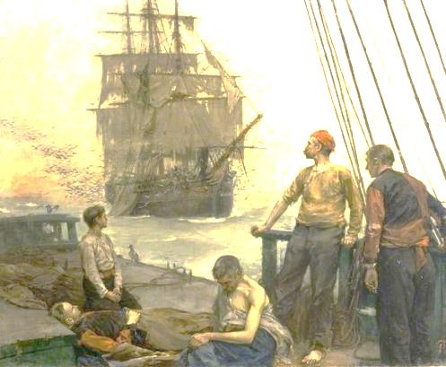The Black Death was a terrible outbreak of deadly diseases that killed millions of people throughout the world. The disease had the biggest impact on the people of Europe and it reached the continent in 1348 thanks to the **resurgence of trade**. In January of 1348, twelve Genoese (Jen-oh-ees) merchant ships arrived in the Italian city-state of **Venice**. The ships had escaped from the trade port of Kaffa where a terrible outbreak of disease had been caused by the Mongolian invasion of the city. The Genoese traders that fled the city accidently brought the Black Death with them to Europe.

The Black Death hadn’t spread to Europe during the early Middle Ages because the feudal system had suppressed trade for nearly 200 years. The people of Europe didn’t really move from place to place so merchants that had the plague didn’t interact with people who didn’t.

Would you rather be poor and safe from disease or rich and exposed to diseases? Why?

________________________________________________________________________________________________________________________

1. Why did the Black Death spread to Europe in 1348? How did the disease reach the city of Venice in January of 1348?

______________________________________________________________________________________________________________________________________________________

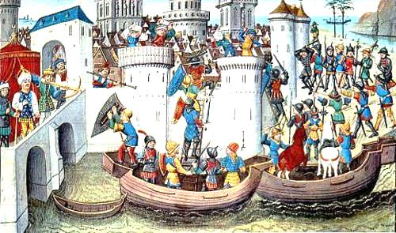When the ships arrived in Venice, the dock workers discovered that the entire crew was either dead or dying. They rushed on to the ships and tried to help the crew and got infected themselves. These workers went home and spread the disease throughout the city. Infected merchants from Venice left the city and spread the disease even further. The Black Death then spread to the city of Pisa several miles away. In February of 1348 the governments of every trading city-state gave orders to **turn any infected ship away** to prevent the spread of the plague.

The city of Venice was the first European urban area to become infected with the Black Death. Very few people in the city were educated so no one knew how to stop it from spreading until it was too late.

What could the Venetians have learned from the Muslims that would have prevented the disease from spreading?

1. Cesarean section C. Margin call
2. Quarantine D. Arbitrage
3. How did the governments of the Italian trading states respond when the disease began to spread throughout Italy in February of 1348?

______________________________________________________________________________________________________________________________________________________

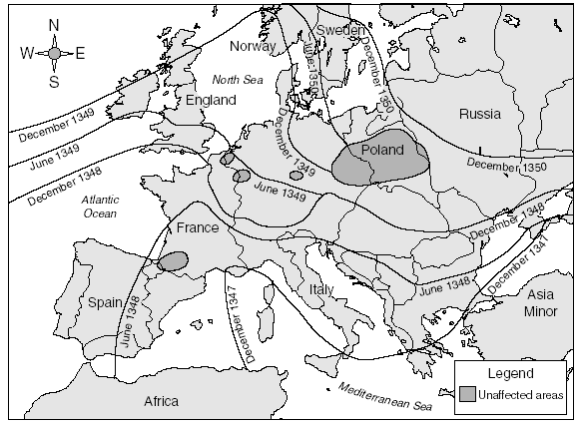The attempts by the various Italian governments to prevent the disease from spreading through their cities accidently caused it to expand into other parts of Europe. The ships that had infected people on them were not allowed to dock in Italy so they left and went to other ports throughout Europe. Between February of 1348 and June of 1349, ships full of plague rats, fleas, and infected people went to France, Germany, and England. No one in these countries had ever heard of the disease before so they didn’t do anything to stop its spread.

The Black Death spread throughout Europe because the people didn’t know what it was or how it was spreading. Most of the Muslims kingdoms of the Islamic Caliphate weren’t affected because they quarantined the infected people.

Why did the Christian Europeans and the Muslims caliphs refuse to cooperate during the Middle Ages? (What conflict did they just finish fighting?)

__________________________________________________________________________________________

1. What happened between February of 1348 and June of 1349 AD?

______________________________________________________________________________________________________________________________________________________

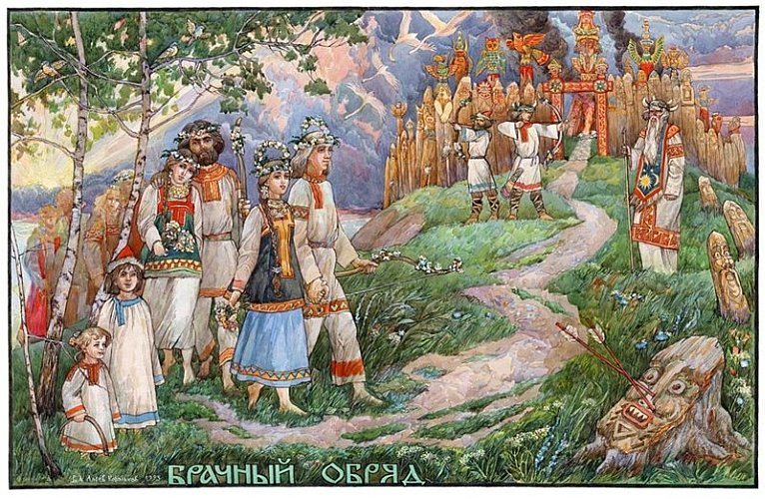Once the plague reached mainland Europe it spread along the trade routes that had developed after the Crusades. Merchants and Crusaders had brought back **silk** and **spices** from the Middle East which restarted trade throughout most of Europe. Rats with fleas infected by the bacteria rode along with these merchants in their bags and carts. Whenever they stopped at trading towns, the rats would leave the bags and the fleas would bite people. By July of 1351, the Black Plague had spread to every major **urban area** in Europe. Even the most rural areas of Russia were affected.

Once it was off the ships, the disease continued to spread throughout the continent because merchants kept moving it around on foot. Most of them didn’t know that they were spreading the plague and most of the people that they traded with got sick.

How do you think people reacted to merchants when they realized that they were the ones spreading the Black Death?

_______________________________________________________________________________________________________

1. How did the disease spread beyond the ports? Where did it spread to by July of 1351?

______________________________________________________________________________________________________________________________________________________

Name: ___________________________ Date: 3/20/17 Period: ___

**Group 3**

Global 1: Spread of the Black Death Timeline **The Plague Becomes a Pandemic**

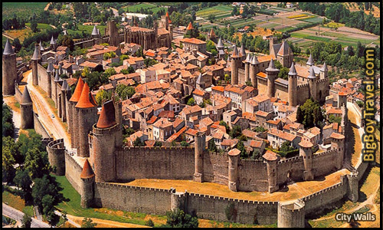The Black Death was a horrible disease that spread through the countries of Europe and killed millions of people during the Middle Ages. Many regions throughout Europe were impacted by its spread but the hardest places that were hit were the **urban areas** of Europe’s towns and cities. By August of 1351, every major town and city in Europe had been infected and the disease went from an epidemic (local regions are affected) to a **pandemic** (the disease had spread across the whole world).

The Black Death had the heaviest impact on European towns and cities like Dover, England. The people were closer together and came into contact more often which made it easy for the disease to spread from person to person.

What did the people of Dover build around their city to protect themselves from outside dangers which accidently trapped them inside with the disease?

_____________________________________________________________________________________________________________________________________________________________________________________________________________________________________

1. What did the Black Death become in August of 1351?

______________________________________________________________________________________________________________________________________________________

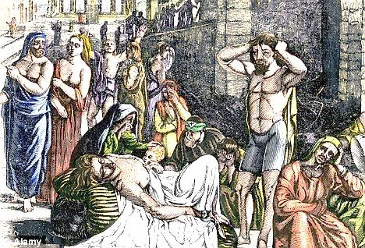Unlike the large, open fields of the countryside, the urban areas of Europe like London, Paris or Kiev were highly susceptible to the Black Death for several reasons. There were no **building codes** in the Middle Ages and cities were constructed with the buildings very close together. Large numbers of people lived and worked very close to each other so it was very easy for the disease to spread from person to person. By September of 1351, the Black Death had jumped from the fleas to people and each infected person became capable of infecting more people by **coughing** or **bleeding** on them.

The Black Death spread from fleas to people when they jumped from rats onto unsuspecting victims and bit them. These people then coughed on more people and spread the disease to them.

How might doctors prevent the spread of the disease from person to person today?

__________________________________________________________________________________

1. How did the Black Death change the way that it spread in September of 1351?

______________________________________________________________________________________________________________________________________________________

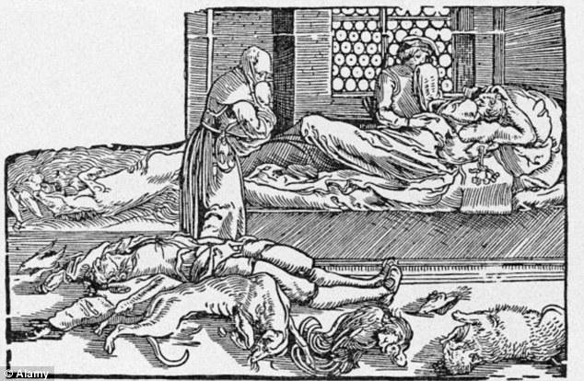Up until 1351 AD towns and cities had been the center of trade as merchants and traders went to **town fairs** around religious holidays to sell their products. Thousands of people flocked to the towns each month to see and buy foreign goods and they ended up getting infected. Between October and November of 1351, the populations of these towns dropped as the infected people died off in droves. By November of 1351, most cities were almost empty and hundreds of small towns were completely abandoned.

The Black Death was so deadly that entire populations of cities were wiped off the face of the Earth. The economic and social systems that organized the towns collapsed.

How do you think the leaders of Europe felt when their towns and economies began to fall apart?

________________________________________________________________________________________

1. What happened to the populations of European towns by November of 1351?

______________________________________________________________________________________________________________________________________________________

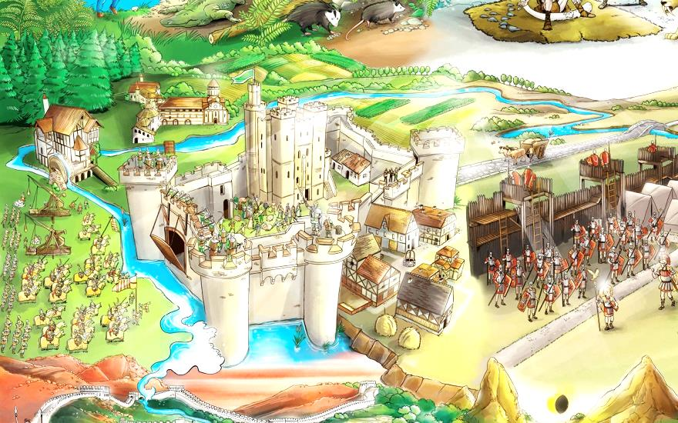Without towns to maintain the trade networks, all of the commerce in Europe collapsed and fell apart worse than it did when the Roman Empire fell. The merchant class of Europe pretty much disappeared and trade stopped all around the continent. Without trade, **feudalism** began to return and by March of 1352 AD most Europeans went back to living on isolated manors. The social class structure that had dominated the early Middle Ages was reestablished and the kings of Europe regained tight control over the peasant class.

Thanks to the disruptive nature of the Black Death, Europeans retreated back to the city-state like manors that had developed after the fall of Rome.

Why do you think the landlords and kings of Europe felt safer in their manor houses than the disease-ridden cities?

____________________________________________________________________________________________________________________________________

1. How did the collapse of European towns affect the people of society in March of 1352?

______________________________________________________________________________________________________________________________________________________

Name: ___________________________ Date: 3/20/17 Period: ___

**Group 4**

Global 1: Spread of the Black Death Timeline **The Plague Affects the Church**

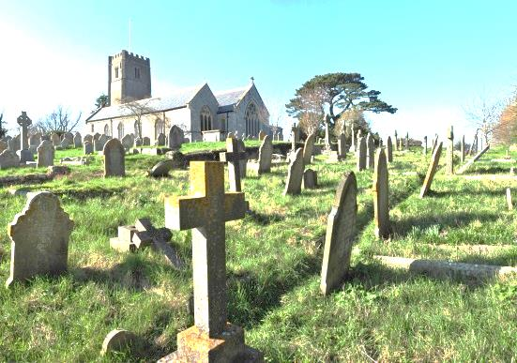The Black Death was a terrible outbreak of bacteria that killed millions of people all over the world between 1330 and 1350. The disease impacted every part of European society from the government to the peasants. However the Bubonic Plague had the biggest impact on the Catholic Church. In 1452 the Black Plague caused the **authority of the church to decline**.

The Catholic Church was a very powerful institution during the Middle Ages but its authority began to slip away thanks to the effects of the Black Death.

Judging from this image, what part of the Church’s land property due to the high death toll?

1. The bell tower 3. The sacristy
2. The alter 4. The graveyard
3. What happened to the authority of the Catholic Church in 1352 as a result of the Black Death?

______________________________________________________________________________________________________________________________________________________

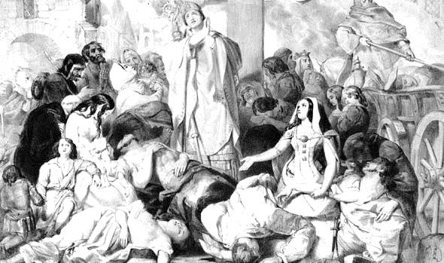Up until 1352 the Church provided guidance and leadership to the people of Europe by giving them religious services and advice on how best to live their lives. The majority of Europeans were very religious and they trusted the word of the church completely. The problem with this was that if anything happened to challenge the authority of the church, then people would lose faith in it and no longer support it. The Black Death became a serious challenge to the church in May of 1352 when the death toll created a **religious crisis** that the church couldn’t solve.

The Catholic Church provided advice and suggestions on the best way to live life for people. They based most of their teachings on the Bible however the church did not have the ability to stop the Black Death from spreading.

Judging from this image, how did religious people attempt to cure themselves of the Black Death in the Middle Ages?

_________________________________________________________________________________________________________________________________

1. What happened to the church in May of 1352 thanks to the spread of the Black Death?

______________________________________________________________________________________________________________________________________________________

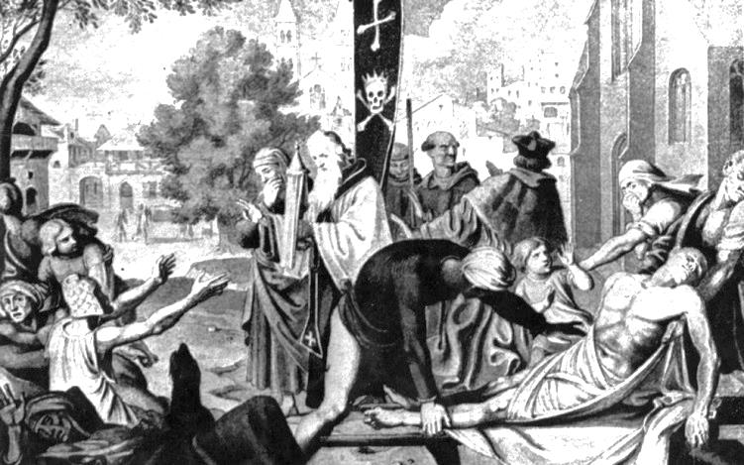Despite the terrible death toll caused by the Black Death the people of Europe were still very dedicated to the church and its teachings. However, as more and more people started dying, European Christians demanded that the church help them. By June of 1352 thousands of people flocked to churches throughout Europe and begged the priests and bishops to cure them or their loved ones. However, instead of getting rid of the disease, it actually caused it to spread further because so many infected people crammed into churches with healthy people and got them infected too.

When the Black Death arrived in Europe the church tried to keep everyone calm but it didn’t work. Religious Christians believed that the power of their god would save them from the plague. Others believed that the disease was punishment for their sins.

What did Church employees do with the dead bodies that piled up around the churches?

______________________________________________________________________________________________________

1. What did the religious people of Europe do in June of 1353 in response to the spread of the Black Death? What did this cause instead?

______________________________________________________________________________________________________________________________________________________

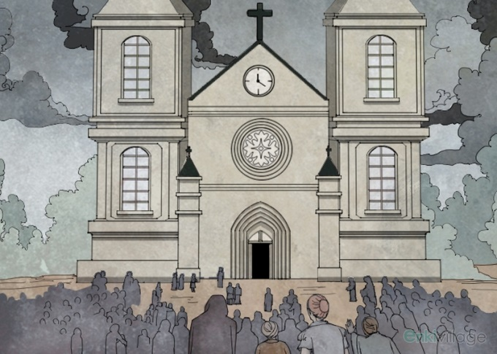In response to the desperate cries of the people, the priests and bishops of the Church tried to help them by telling them to pray or repent for their sins. Thousands of priests got infected themselves while trying to help the sick and their replacements were less willing to work with the sick and dead. The people of Europe slowly realized that the church didn’t have the power to help them and millions of people lost faith in its leadership. By May of 1355, the church **had lost hundreds of thousands of followers** and it never regained the authority that it had before the outbreak of the Black Death.

Institutions in Europe during the Middle Ages became powerful only with the support of the people. When the people stopped going to church, it lost most of its authority and couldn’t tell what to do Europeans as easily as before.

If no one was listening to the government anymore would you continue to support it? Why or why not?

_________________________________________________________________________________________________________________________________________________________

1. What happened to Church membership in May of 1355 AD thanks to the effects of the Black Death?

______________________________________________________________________________________________________________________________________________________

Name: ___________________________ Date: 3/20/17 Period: ___

**Group 5**

Global 1: Spread of the Black Death Timeline **The Peasants Rise**

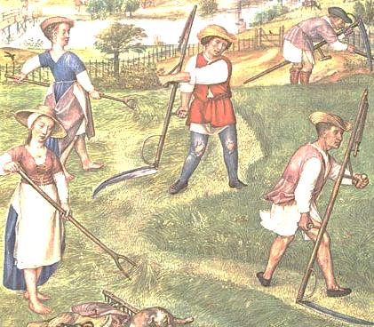 The Black Death was an incredibly deadly strain of bacteria that killed millions of people all over the world. The massive death toll caused by its spread had a heavy impact on every social class of Europe. However the disease had the largest impact on the peasant class of Europe as the shifts in population allowed the **peasant class to demand more rights** in 1355.

The peasants were responsible for doing most of the work on the farms and feudal manor properties. They worked long hours and did not make much money. In fact, they were mostly paid with a portion of the crops that they grew and the rest were given to the upper class.

Do you think this economic system was fair for the peasants? Why or why not?

________________________________________________________________________________________________________________________________________________________________________________________________

1. What did the peasant class do in 1355 AD as a result of the effects of the Black Death?

____________________________________________________________________________________________________________________________________________________________

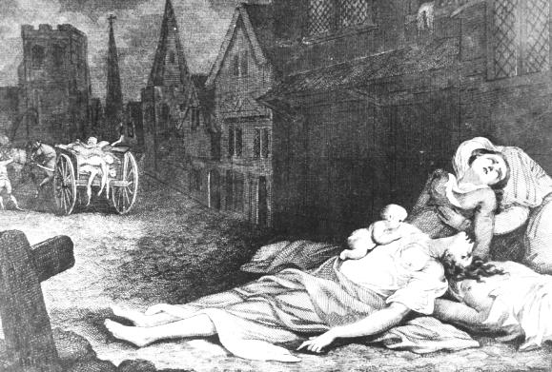When the Black Death arrived in Europe in 1347 the peasants of Europe were mostly confined to the manors where they worked on the farms and performed labor and maintenance on the property. Most of them were isolated from the outbreaks of disease when they first started because very few peasants lived in towns. However in 1355 the Black Death spread to farms and even the most isolated manors by merchants and knights returning from the Crusades. The peasants didn’t have any control over who they interacted with because they weren’t allowed to leave the manors. As a result, by January of 1355, millions of peasants had become infected by the Bubonic Plague.

Peasants were hit hard by the Black Death because they didn’t have large, expensive houses to escape to. Instead peasants had to sit there and wait for death as their family and friends got sick and died around them.

How do you think the peasants felt about the upper class members who were wealthy enough to escape the disease?

________________________________________________________________________________________________________________________

1. Why couldn’t the peasants escape from the spread of the Black Death? What happened by January of 1355 as a result?

____________________________________________________________________________________________________________________________________________________________

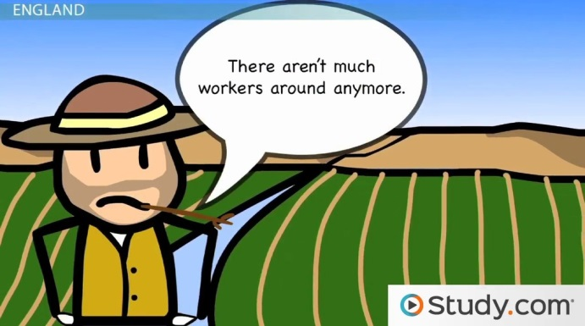The Black Death killed so many peasants that it completely shifted the entire relationship between the different social classes of Europe. In total, the Black Death killed 200 million people, over a quarter of Europe’s entire population. In 1360 the peasants realized that with less people to work on the farms, they could demand more money for their work. The landlords and nobles agreed to pay them slightly more for their work and the peasants moved up the social ladder of Europe slightly.

Thanks to the Black Death there were suddenly much fewer workers to do the labor on European farms. For the first time in 500 years, labor was more valuable than land as landlords fought over peasants to work on their farms.

What would you demand if you were a peasant during this time period?

__________________________________________________________________________________________________________________________

1. What did the peasants do about the labor shortage in 1360? How did it affect them?

____________________________________________________________________________________________________________________________________________________________

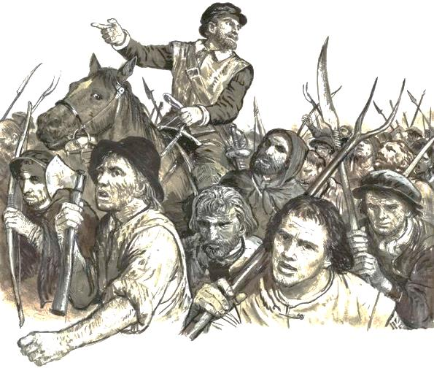When the nobles and landlords gave in to their demands for higher wages, the peasants demanded better living conditions, shorter working hours and even a small role in the government. The kings and nobles of Europe immediately refused and cracked down on the peasants with their armies. For twenty one years between 1360 and 1381, the peasants tried to reason with the upper class but when it didn’t seem as if anything would change, they **revolted against the government in 1381**. The peasants started riots, refused to work and attacked nobles whenever they came out of their castles. In the chaos, the Black Death spread even further and more people died. As a result, the late 1300s remained a chaotic and violent time period.

The Peasant Revolt of 1381 was the first time in European history that the lower class fought with the upper class to get better rights.

If you were alive in this time period would you support the peasants or the upper classes? Why?

_____________________________________________________________________________________________________________________________________________

1. What did the peasants demand from the nobles between 1360 and 1381?

____________________________________________________________________________________________________________________________________________________________

1. What did the peasants do in 1381 when the nobles refused their demands?

____________________________________________________________________________________________________________________________________________________________

Name: ___________________________ Date: 3/20/17 Period: ___

**Group 6**

Global 1: Spread of the Black Death Timeline **Europeans Respond to the Plague**

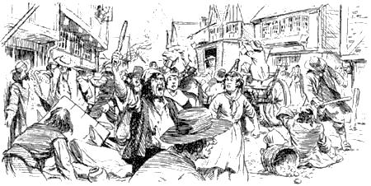The Black Death was the nickname given to a horrific outbreak of a disease called the Bubonic Plague. Before it subsided, the Black Death killed over 200 million people and completely changed the socioeconomic landscape of Europe. The plague was responsible for the death of countless people but the violent reaction of middle and upper class Europeans added to the suffering and destruction of the time period. For nearly twenty years between 1381 and 1401, the people of Europe **severely overreacted to the effects of the disease**.

The people of Europe were understandably upset and scared by the effects of the disease and overreacted by rioting and blaming innocent people for its spread.

Do you think it was reasonable for people to behave this way? Why or why not?

___________________________________________________________________________________________________________________________________________________

1. How did Europeans respond to the outbreak of the Black Death between 1381 and 1401?

____________________________________________________________________________________________________________________________________________________________

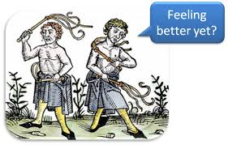 The people of Europe were mostly uneducated during the Middle Ages but they weren’t stupid. They knew what a disease was and that it can spread from person to person. However they didn’t know how or why it was spreading so it made everyone very nervous. Different explanations for why the disease was spreading began to develop during this time and some people believed them while some people believed others. One of the prevailing explanations developed in 1402 AD when religious Christians began believing that **god was punishing them for their sins**. They thought that the outbreak of the plague was a punishment for them for any actions that went against the teachings of the Bible.

Many religious Christians believed that they were being punished for something that they did because they didn’t understand why the plague was spreading. Some Christians believed that if they punished themselves in other ways, then the plague would end so they flogged themselves.

How do you think these Christians felt when the Plague continued even though they performed self-flagellation?

________________________________________________________________________________________________________________________

1. What did very religious Christians begin to believe about the plague in 1402?

____________________________________________________________________________________________________________________________________________________________

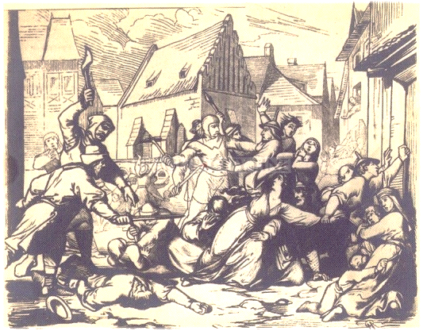When religious practice failed to stop the spread of the plague, people turned to other explanations. One of the most damaging ideas that Christians adopted was that the **Jewish population of Europe was causing the disease**. Many Jewish settlements were isolated from the Christian majorities so they did not suffer as badly from the disease and overzealous Christians believed that because they weren’t really affected, then the Jews must have been responsible for the widespread infections. In 1403, a rumor began that the Jewish population of Europe was **poisoning the drinking water**. Many peasants, knights, and even a few nobles became enraged when they heard this rumor and attacked Jewish communities in raids called **pogroms**. Thousands of innocent Jewish people were murdered in these raids and the Black Plague was accidently spread into their villages which killed even more.

Throughout history, Jewish communities were targeted by intolerant majorities but it reached an all-time high during the Middle Ages and during the Black Death in particular. Unfortunately, things got a lot worse for the Jews of Europe before they got better.

Do you think this treatment of innocent people was fair? Why or why not?

_____________________________________________________________________________________________________________________________________________________________________________________________

1. Why were Jews targeted by overzealous Christians in 1403? Why did the Christians think this and how did they react to this rumor?

__________________________________________________________________________________________________________________________________________________________________________________________________________________________________________

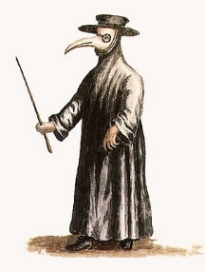The people of Europe continued to overreact to the effects of the Black Death until literally every person who wasn’t immune died off. The Black Death continued to resurface and kill people for an additional two hundred and sixty years. The plague finally subsided in 1666 AD when the **Great Fire of London** killed the rat population of the city which eliminated the source of the infection for several years. After that, the plague simply became part of life like AIDS or Cancer is for society today. Finally, in 1967 an antibiotic called **Doxycycline** was invented that completely kills the plague on contact and the threat of the Black Death finally came to an end.

Medieval doctors like this one thought that the Bubonic Plague was coming from “foul air” that was released from cracks in the ground. No one knew how to really treat the disease for decades and the only reason it stopped spreading is because some people had natural immunities that they passed down to their children.

1. What happened in 1666 that helped reduce the impact of the plague for the first time?

____________________________________________________________________________________________________________________________________________________________

1. What did modern doctors invent in 1967 that ended the threat of the Black Death permanently?

____________________________________________________________________________________________________________________________________________________________